Annex L: Rationale and Process behind the Selection of the Project Overall Landscape and the Three Trial Landscapes
Introduction
The ‘Managing Together’ project is funded by the sixth programme cycle of the Global Environment Facility (GEF). The Ministry of Mahaweli Development and Environment (MoMDE) implements the project as the national focal point for the GEF, and the United Nations Development Programme (UNDP) is acting as the GEF agency, while the International Union for Conservation of Nature (IUCN) is the agency leading the project design during the Project Preparatory Grant (PPG) phase. The project aims to take an integrated, community-centred and ecosystem-based approach to mainstream biodiversity-sensitive best practices into the development of forestry, agriculture and tourism sectors. Furthermore, this project will facilitate its environmental and social benefits to be fairly distributed among the local communities ensuring a sustainable economic development that would extend beyond the project period. This chapter aims to describe the methodology that was followed to select the overall Project Landscape (PL) and three Trial Landscapes (TLs), in which the project activities are to take place at the onset of project’s commencement.
Rationale
The project’s outcomes as described by the Project Identification Form (PIF) aim to have a positive impact on the sectors of agriculture, tourism and biodiversity in an integrated manner. Due to the diverse ways in which the above three sectors impact on the environment, the selection of a suitable project Landscape was a complicated endeavour. Further complicating the selection process was the need to consider the dynamic impact the project would have on the social, economic and environmental fabric of the project landscape and how these impacts change according to scale and scope of the activities. Lastly, the limitations of funding (USD 3.3 million) with a need for six times co-financing (USD 21 million) was also considered when conceptualising the PL and TLs, which are nested within it.
The PIF states that a “Landscape Approach” should be followed when considering the spatial distribution of the project’s activities. Such an approach compliments the above mentioned aspects which required consideration. This is because it would be at such a scale where the interplay between the three sectors of interest (Agriculture, Forestry and Tourism) would be best conceptualised for a coherent and sustainable project to be designed. So that, an initial decision was made that the PL of interest would best be associated with a river basin, that extends into its seascape. That way, we assured (a) a natural boundary for the PL, (b) a clear ecological flow by the means of water that further ensures the connectedness of spatial entities and (c) a landscape that continues into a seascape.
Further, the PIF specifies the project area as the Northern region of Sri Lanka (i.e. the Northern and North-Central Provinces of the island), while setting optimistic biodiversity targets in terms of extents of High Conservation Value Forests (HCVFs) and High Carbon Stock Forests (HCSFs) to be conserved, managed and enhanced. They are, (a) to sustainably manage at least 214,213 ha of HCVFs and HCSFs, (b) afforestation or reforestation of at least 1,000 ha sequestering 193,549 tCO2-eq/10yr. (c) 30,000 ha of new HCVFs and HCSFs to be identified and declared as protected, and (d) forest landscape restoration (enrichment planting) of degraded forests in 20,000 ha, where sustainable land & forest management will improves habitat connectivity and increase carbon sequestration by 2,876,566 tCO2-eq/10yr. Provided the secondary nature of most forests within the dry zone of Sri Lanka, we estimated the project landscape to span over at least 1,500 km² in order to facilitate the achievement of above targets.
Among the 103 river basins in Sri Lanka 14 are identified as major river basins, while only one of them (i.e. Malwathu Oya or the Aruvi Aru) flows across the Provinces of Northern and North-Central. Nevertheless, two watersheds with an area of over 1,500 km² are found within this region, namely Malwathu Oya (3839 km² of landscape + 1012 km² of seascape) and Yan Oya (1550 km² of landscape + 107 km² of seascape) (see Figure 1).
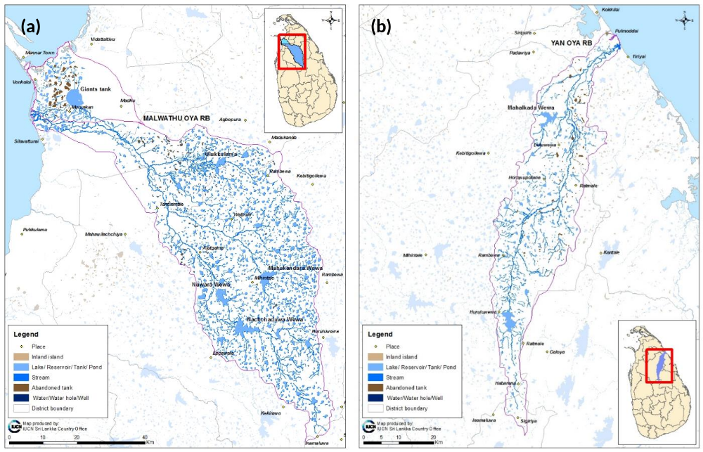
Figure 1. Eligible project landscapes (a) Malwathu Oya watershed, and (b) Yan Oya watershed

A multi-criteria decision making exercise was used to make an objective selection of the best river basin for the prescribed project, “Managing Together”. A rational scoring scheme was developed to compare a multitude of criteria between the two basins, with the intention of being objective as possible in making a choice between the above two eligible project landscapes.
The project team consisted of experts in the sectors of biodiversity (both species and ecosystems), tourism, agriculture and land use, forestry, socio economics as well as the spatial analysis using geographical information systems (GIS). Factors considered for the analysis were mainly based on the GEF focal areas for their funding cycle 6 (viz. Globally significant Biodiversity, Sustainable Forest Management and Land Degradation) and the two main production sectors (viz. Agriculture and Forestry) and the key economic driver (i.e. Tourism) recognised to be integrated during the implementation of this project.
The biodiversity was considered here in its two macro and tangible levels, namely the ecosystem diversity and species diversity. Therefore, the analysis was conducted altogether for five major sectors (Ecosystem Diversity, Species Diversity, Sustainable Forest Management, Sustainable Tourism and Sustainable Agriculture), while a single or several major criteria, together with a multitude of sub criteria were identified within each sector. Each sub criterion could be related to one or more of GEF focal areas, and they were further categorized as strengths, weaknesses, opportunities or threats for the selection of the concerned riverbasin as the PL. Strengths and opportunities were given positive (+) scores while weaknesses and threats were scored negative (-), while a scoring scheme was devised with different weights for each sub criteria based on expert opinion. Then the scoring was conducted with available databases at IUCN-SL with necessary updating. Data for ecosystem and species diversity were based on the published literature on the watersheds plus opportunistic data collected by IUCN-SL field teams, and the biodiversity specialists in the current project team during various missions within these two river basins within the past five years. Data used in the other three sectors for the selection process were largely collected from GIS sources, again with updated shape files available with the IUCN-SL GIS specialist. The PL selection methodology along the multi-criteria decision making process with relevant criteria and scoring schemes and final scores for the two basins are provided in the Table 1, with relevant data summaries as justifications on scores for each sub criteria.

Selection of the Project Landscape
Based on the data summarised in the Table 1, a multi-criteria based scoring exercise was conducted to compare Malwathu Oya and Yan Oya river basins in order to find the best landscape for the project “Managing Together”. The scoresheets for species diversity, ecosystem diversity, sustainable forest management, sustainable agriculture and sustainable tourism are provided in the table 1. The analysis finally selected the Malwathu Oya basin as the project landscape with a final score of 90.9%, considerably higher than that of the Yan Oya, 69.6%.
Nevertheless, it was also observed that several contiguous natural forest habitats, which starts within the Malwathu Oya basin are extending beyond the river basin boundary into trans basin forest patches, while it was also identified that the ecological connectivity through these extensions are of high conservation value. Further, the Malwathu Oya water has been diverted through an ancient anicut at Thekkama by Kind Datusena (455-473 A.D.) spreading its ecological flow into the adjacent river basin of Nay Aru in the North.
Therefore, the PL has been identified along the Malwatu Oya (Aruvi Aru) basin and the adjacent environs including contagious forest patches extending extralimital to the river basin boundary. Hence the PL broadly encompasses the adjacent river basins of Modaragam Aru, Kal Aru and Nay Aru in addition to the Malwathu Oya. Further the Seascape adjacent to the Malwathu Oya estuary is also considered as a part of this project.
Globally significant species that will receive enhanced protection through project activities within this landscape include the critically endangered orange-finned labeo (Labeo lankae) with restricted range in Malwathu Oya, the locally endangered Asian elephant (Elephas maximus), rusty-spotted cat (Prionailurus rubiginosus), leopard (Panthera pardus), and the sloth bear (Melursus ursinus), as well as the vulnerable Blotch bowfinger gecko (Cyrtodactylus yakhuna). Similarly, several of globally threatened marine species such as the dugong (Dugong dugon), five species of sea turtles, the hump head wrasse (Cheilinus undulatus) and indo-pacific humpbacked dolphin (Sousa chinensis) will receive enhanced protection within the seascape.

Table 1. Multi criteria comparison between Malwathu Oya and Yan Oya watersheds for the species diversity, ecosystem diversity, sustainable forest management, sustainable agriculture and sustainable tourism aspects.
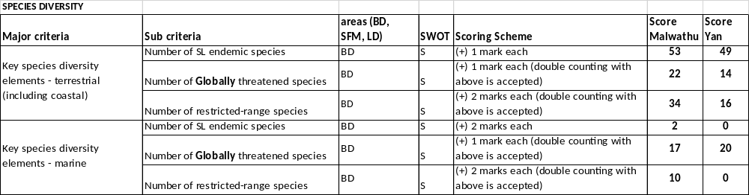

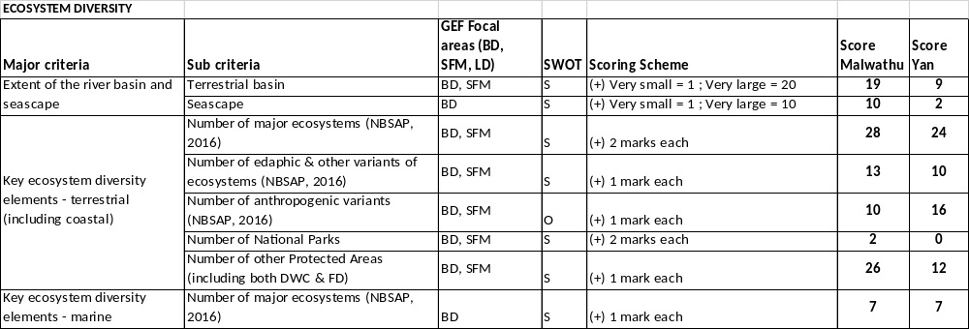

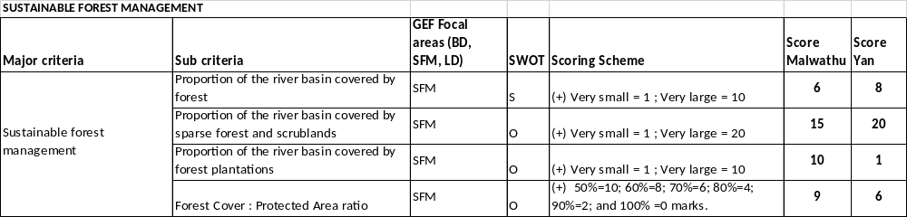

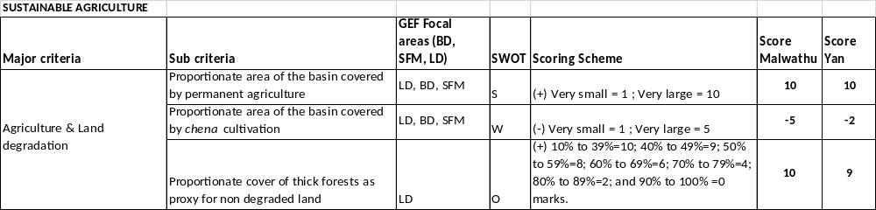

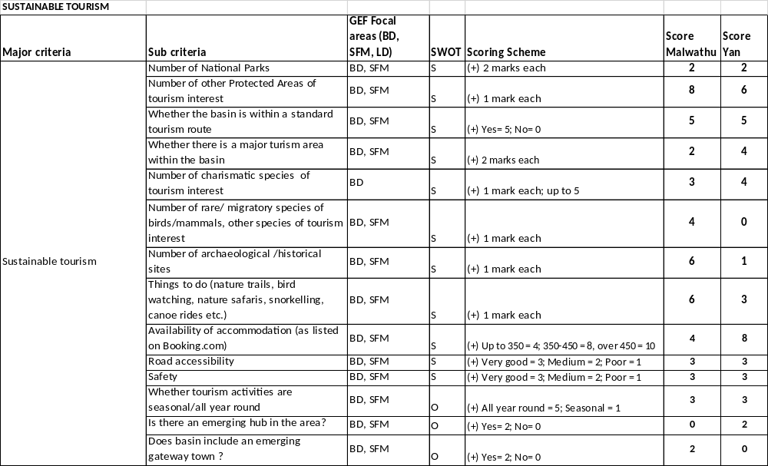

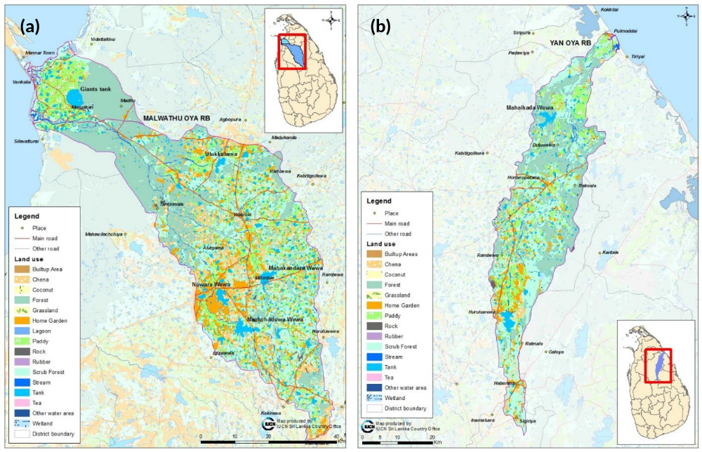
Figure 2. Land use categories (a) Malwathu Oya watershed, and (b) Yan Oya watershed

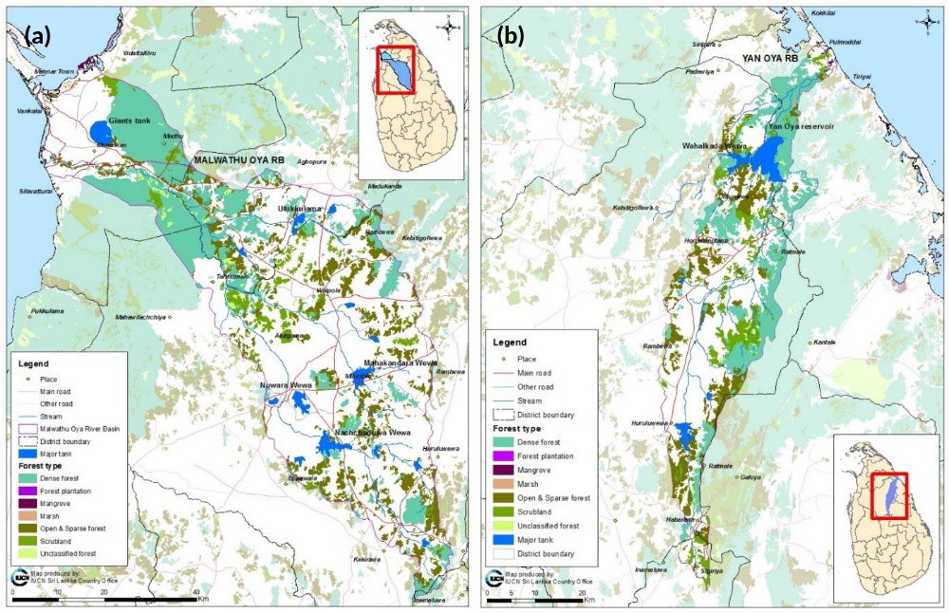
Figure 3. Forest cover (a) Malwathu Oya watershed, and (b) Yan Oya watershed
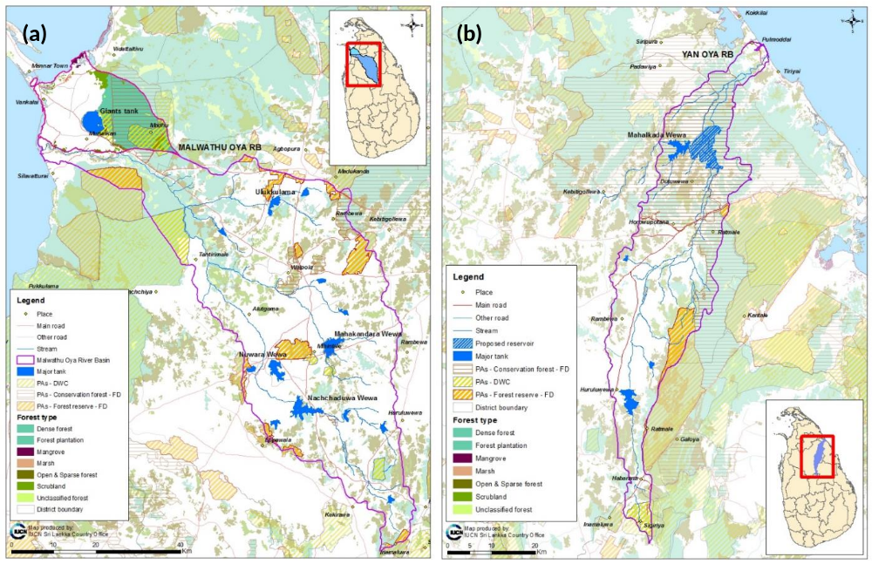
Figure 4. Protected areas (a) Malwathu Oya watershed, and (b) Yan Oya watershed

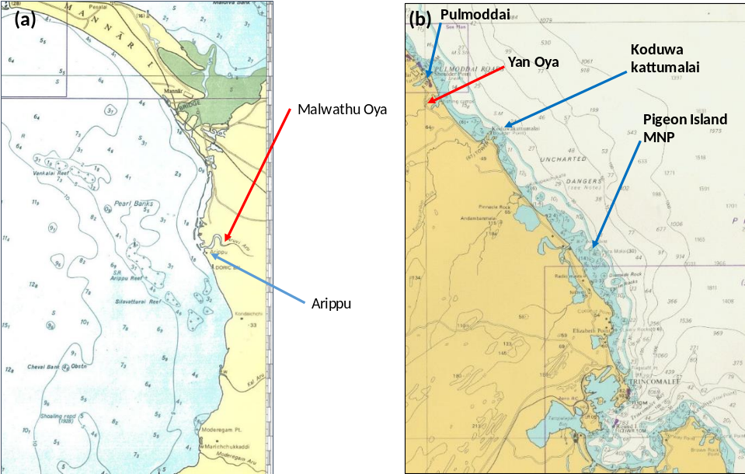
Figure 5. Features in the seascapes adjacent to the estuaries of (a) Malwathu Oya watershed, and (b) Yan Oya watershed

Selection of the Project’s Trial Landscapes
A similar but less objective approach was followed with further inputs from expert knowledge on distribution of selected globally significant species and the biodiversity conservation in general, when selecting Trial Landscapes for the ground level implementation of project activities. Further, the ongoing and planned development projects/activities in the landscape (particularly those pertaining to the Lower Malwathu Oya reservoir and irrigation development project, and tourism infrastructure development plans especially in Mannar, etc.) were also considered for Trial Landscape selection.
Thee Trial Landscapes have been identified for project activities to be conducted based on;
- the available data on the biodiversity (especially the ecosystems and threatened species) of global significance, socio-economics and ongoing or planned projects
- expert opinion on the potential of meeting project objectives on major sectors to be integrated (Agriculture, Forestry and Tourism), and being in line with the GEF focal areas for their sixth funding cycle (Biodiversity, Land Degradation and Sustainable Forest Management). That is the potential to minimize land degradation through sustainable land use practices in agriculture and forestry sectors, sustainable forest management and eco-tourism ventures.
- potential to meet the land extent based targets of the project in sustainable forest management, declaration of protected areas, forest landscape restoration and afforestation.
- ability to aligning with government policies, plans and programmes – due to limited resource availability in the project (USD 3.3 million of GEF Funding) such aligning will help complementarity and sustenance of project activities. Following were specifically looked into;
Strategic Environment Assessment for the North, GEF Environmental Sensitive Areas Project, GEF Dugong and Sea Grass Conservation Project, Wildlife Management Plans for Upper Elahera Canal Project, National REDD+ Investment Framework, GCF Cascades project, National Biodiversity Strategic Action Plan (NBSAP), Biodiversity Financing Initiative (BIOFIN), Ecosystem Conservation and Management Project (ESCAMP), Sri Lanka Tourism Strategic Plan 2017-2020, Good Agriculture Practices of the Department of Agriculture (GAP), Agriculture Sector Modernisation Project, Wilpattu National Park and Influence Zone Management in Sri Lanka and Bonn Challenge pledge for forest restoration in Sri Lanka related to Nationally Determined Commitments (NDCs) to United National Framework Convention on Climate Change.
The selected Trial Landscapes were subsequently endorsed by the Technical Advisory Committee (TAC) appointed by the MoMDE to guide the project designing phase. They are,

- Trial Landscape 1: Maminiya Oya, Upper Kanadara Oya, Upper Weli Oya and Lower Weli Oya sub watersheds of the Malwathu Oya.
- Trial Landscape 2: Malwathu Oya riverine forests including the Mavillu Conservation Forest and other forests connecting the Madhu Road and Wilpattu National Parks also extending to the Giant’s tank and its downstream feeder tank system.
- Trial Landscape 3: The Malwatu Oya Estuary, and the adjacent sea scape (including coral reefs of Vankalai, Arippu, and Silavaturai, Pearl Banks of Mannar, and Cheval Bank and the sea grass beds in the shallow coastal seas of the area.
The area which will be further developed in the recent future through the Lower Malwathu Oya irrigation and hydroelectricity project are intentionally avoided for any proposed activity.
The project’s Trial Landscapes would mainly fall under the administrative purview of the Divisional Secretariat Divisions of Madhu, Mannar, Mihintale, Musalai, Nachchaduwa, Nanaddan, Nuwaragam Palatha Central, Nuwaragam Palatha East, Rambewa, Thirappane, Vengalacheddikulam and Vilachchiya (see Figure 7).

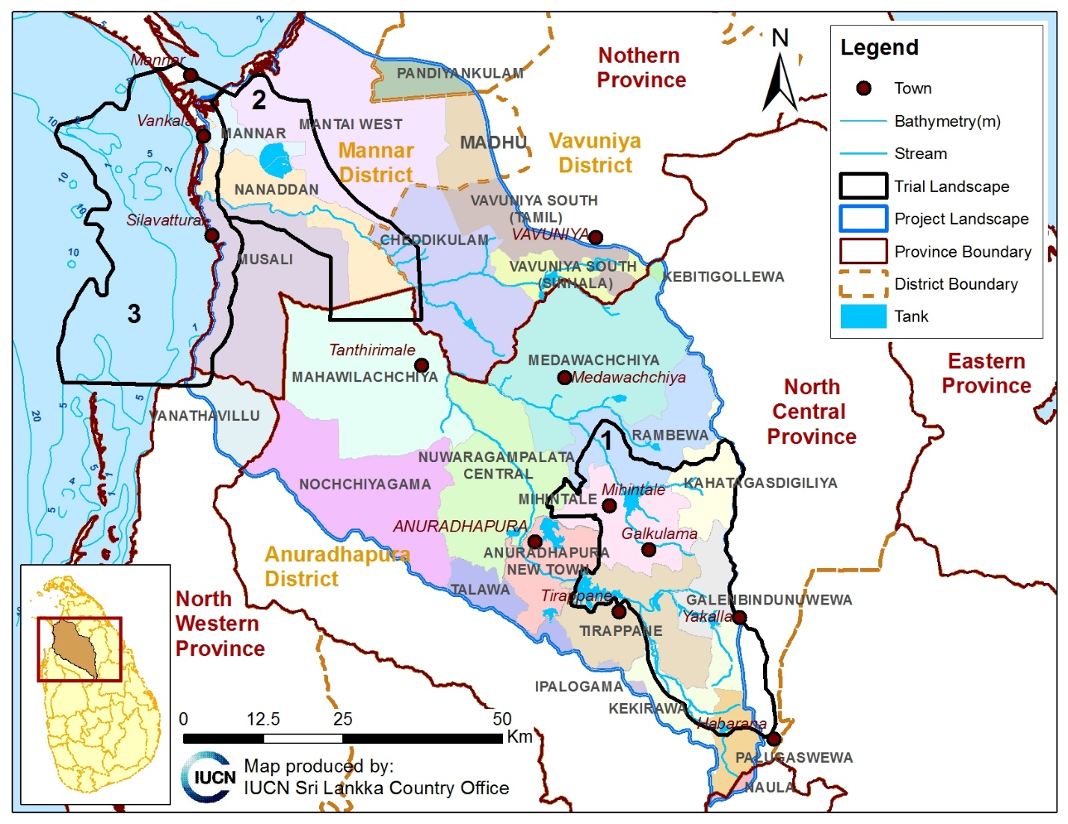
Figure 6. The Project Landscape and the three selected Trial Landscapes

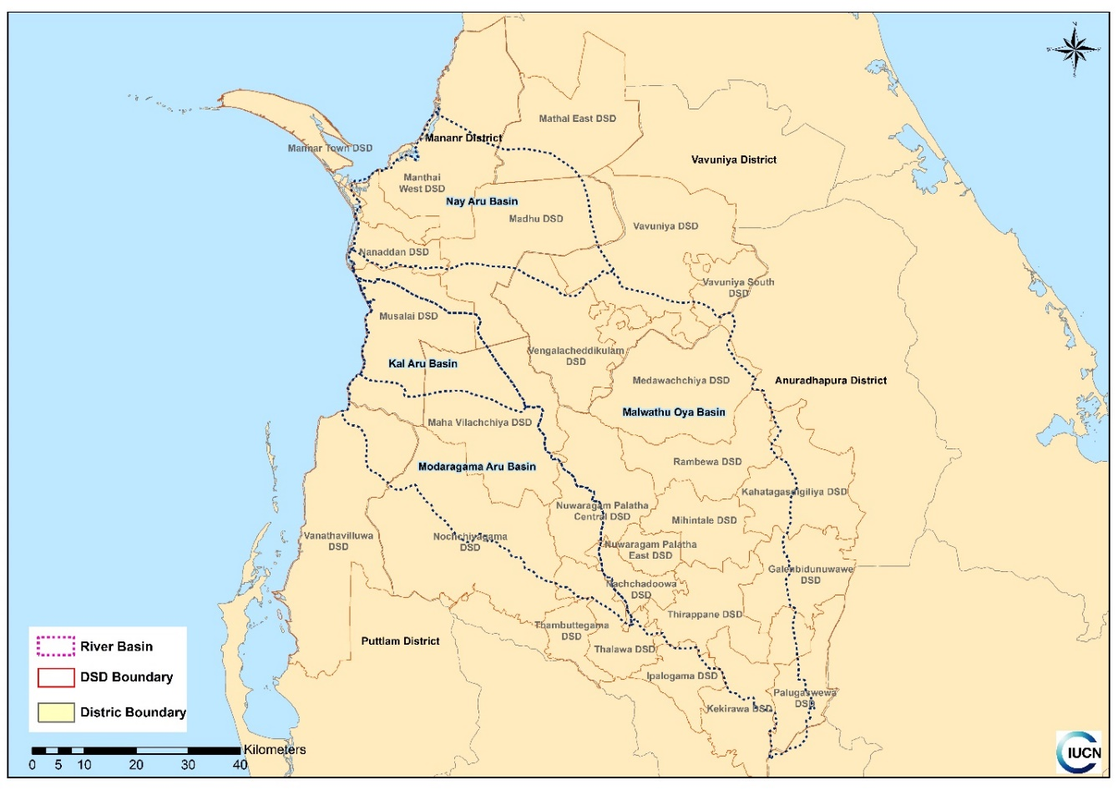
Figure 7. Divisional Secretary Divisions within the selected project landscape and the four activity sites
Annex 1: Summary data and scoring for the project landscape selection using multi-criteria decision making process
